LP3 QMS TESTING PDF

URL:- <https://cloudcounselage.co.in/#/>

**TESTING AUDIT SPECIFICATIONS**

|  |  |
| --- | --- |
| **PERFORMANCE 🡪** | Audits for metrics like first paint and time to interactive to determine lag |
| **BEST PRATICE 🡪** | Looks for everything from HTTPS usage to correct image aspect ratios. |
| **ACCESSIBILITY 🡪** | Checks for best practices to ensure your site is discoverable. |
| **SEO 🡪** | Checks for common issues that may prevent users from accessing your content. |
|  |  |

**LOGIN PAGE URL:-<https://cloudcounselage.co.in/#/login>**

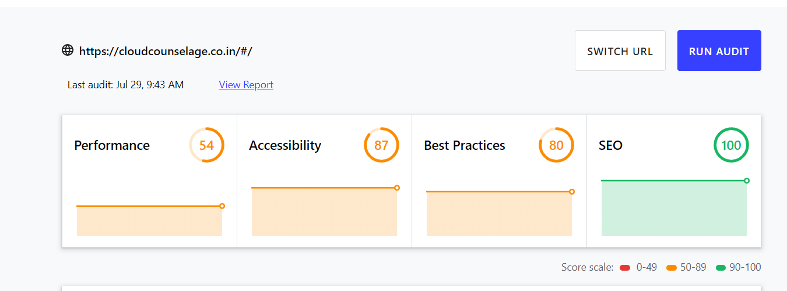

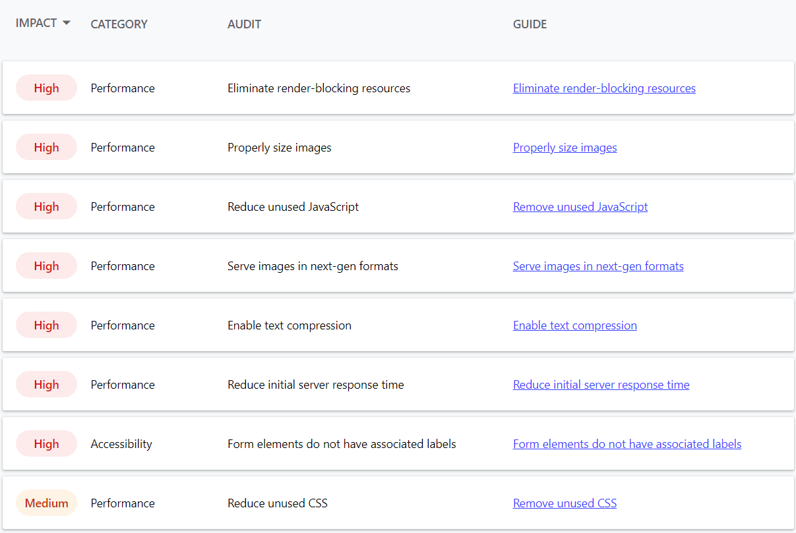

**HOME PAGE URL:-<https://cloudcounselage.co.in/#/>**

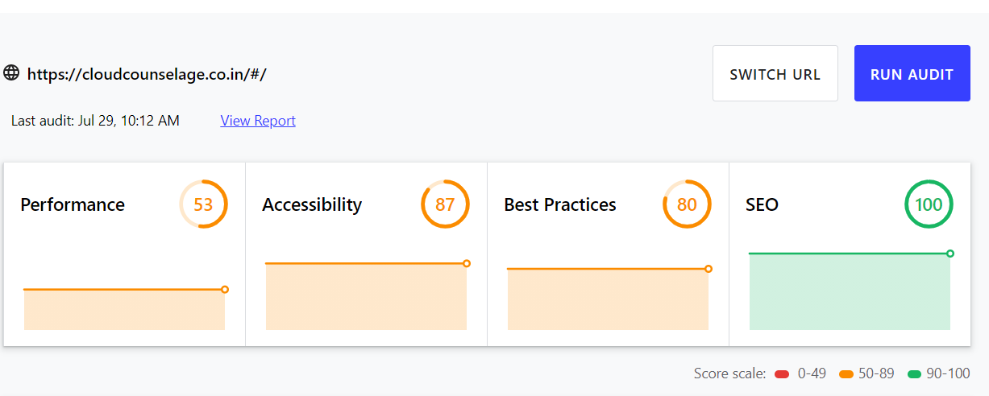

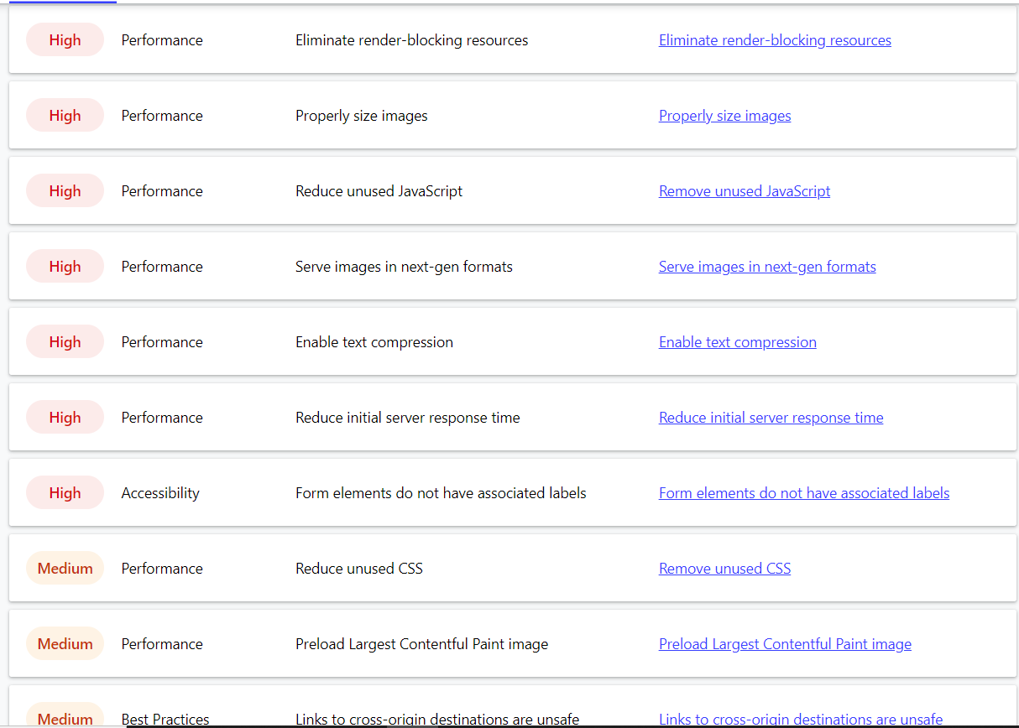

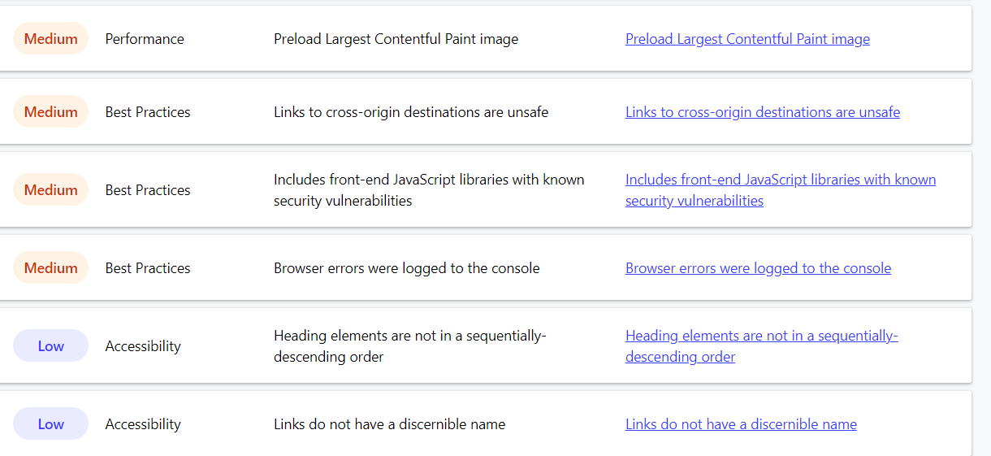

**BROUSE COURSE URL:-** [**https://cloudcounselage.co.in/#/course**](https://cloudcounselage.co.in/#/course)

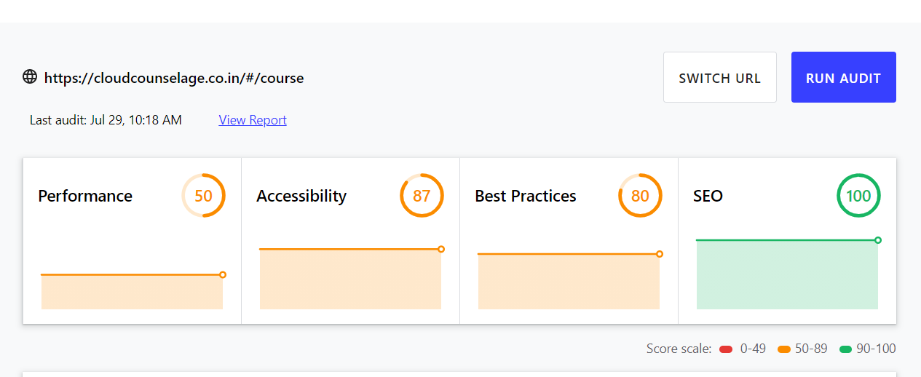

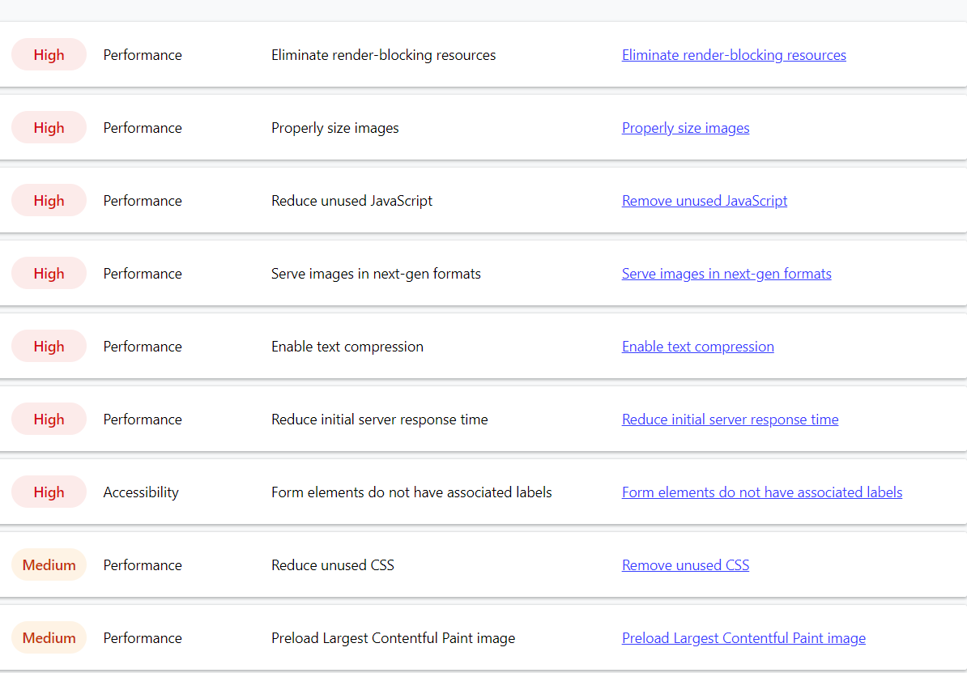

**BROUSE VIDEOS** [**URL:-https://cloudcounselage.co.in/#/video**](URL:-https://cloudcounselage.co.in/#/video)

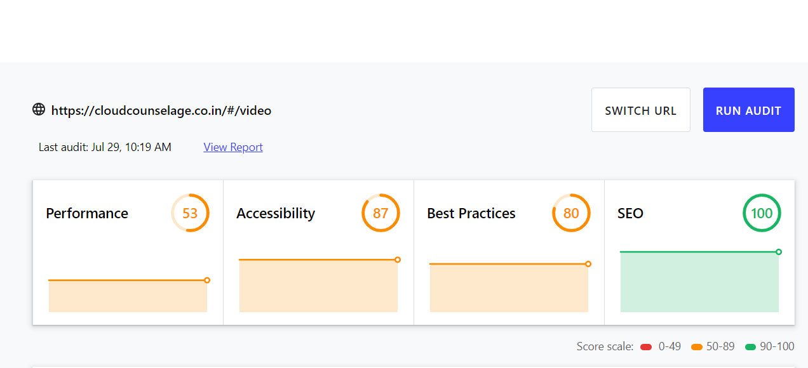

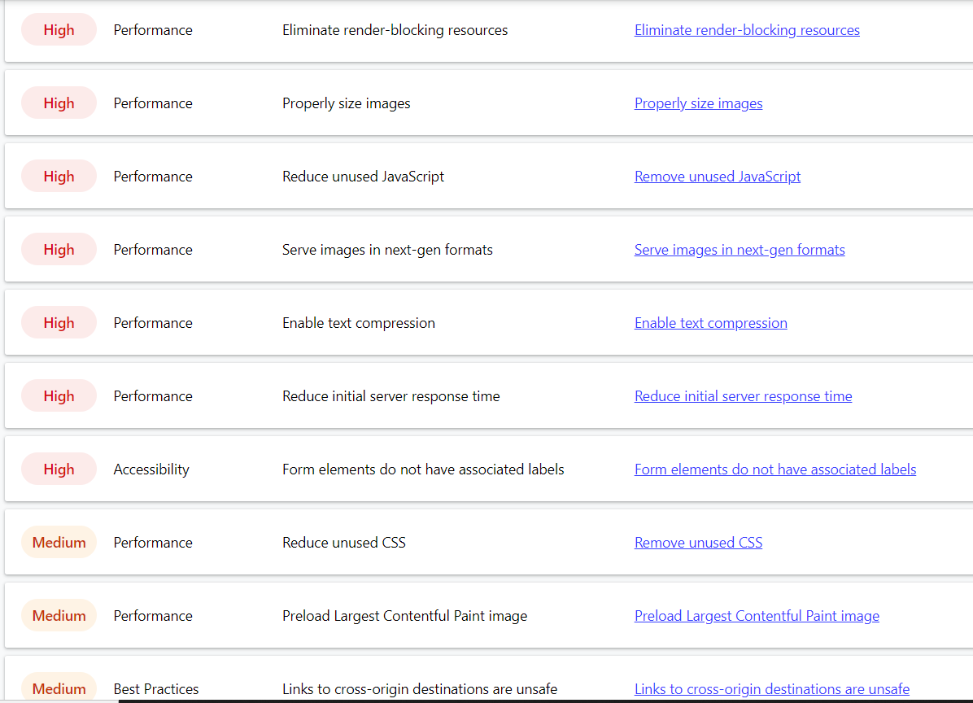

**FAQ URL:-**[**https://cloudcounselage.co.in/#/faq**](https://cloudcounselage.co.in/#/faq)

